Fundaments of

Artificial Intelligence

Course Details
Title: Artificial Intelligence
Code: DAT6002 S2_25
Term: Spring 2026
Assessment: WRIT1

Student Details
Tom Rowan ST20285213

Project Tutor
Dr. Imtiaz Hussain Khan

Table of Contents
Part 1 - Symbolic AI 3
Task 1: Semantic Network Design for Medieval Weaponry 3
Structural Design and Abstraction 3
Inheritance 4
Task 2: Semantic Network Implementation 5
Python Implementation 5
Prolog Implementation 6
Sample Queries 8
Ethical Considerations 13
Part 2: Connectionist Methods 14
Dataset Preparation 14
A Biased Dataset 14
Outliers 15
Encoding and Scaling 19
One-Hot Encoding 19
Binary Variable Encoding 19
Normalisation Functions 19
Removal of Problematic Features 20
Correlation with Dependent Variable ‘y’ 21
Post Processing 22
Implementation of ANN From Scratch 23
Network Architecture 23
Feed Forward Pass 24
Back Propagation 24
Weight and Bias Update Step 25
Performance Evaluation 26
ANN Implementation with Libraries 30
Choice of Library 30
Model Parameter Configuration 30
Performance Comparison 31
Advantages and Disadvantages 32
Parameter Tuning and Model Optimisation 34
GridSearchCV 34
Genetic Algorithm Optimisation 36
References 40
Part 1 – Symbolic AI 40
Part 2 – Connectionist Methods 41

Part 1 - Symbolic AI

Task 1: Semantic Network Design for Medieval Weaponry
A semantic network is a way of representing knowledge about a subject by modelling relationships and attributes as ‘nodes’ and connecting ‘edges’ on a graph. In this project, the subject being represented is medieval weaponry, with the ‘medieval period’ defined as starting with the fall of the Western Roman Empire in 476 AD through to the beginning of the Protestant Renaissance Period in 1517 AD. (Study.com n.d., Metropolitan Museum 1991, Wikipedia 2026)

Structural Design and Abstraction
The semantic network was constructed using a hierarchical classification system, grouping items by shared properties and function. This reduces redundancy and follows the taxonomical classification found in biological classification which groups organisms based on shared ancestral traits (Campbell 2005).

An attribute is a possible general characteristic known to the network, while a property is an instance of an attribute that is attached to a distinct item.

In the design phase, choices were made about the abstraction based on the frequency of shared attributes. When several weapons shared properties (such as the combination of a blade, a hilt, and use at close quarters) it became more efficient to abstract these properties into a dedicated intermediate node, such as ‘bladed_hand_weapon’. This choice reduces the need to repeat identical ‘has_a’ facts across multiple leaves, allowing for a neater hierarchy.

Items that are closer to the root of the relationship tree have fewer but more general properties. Conversely, objects that are leaves are likely to have more properties. Items inherit properties from objects that are closer to the root; these can be overridden (hidden) by more specific properties.

The design separates the taxonomy where an item belongs to a class from attributes belonging to the item.

A challenge emerged in this design regarding whether to use multiple inheritance. While a tree structure works for most weapons, certain items are not simple to categorise. For example, trebuchet functions both as a siege weapon and a ranged weapon.

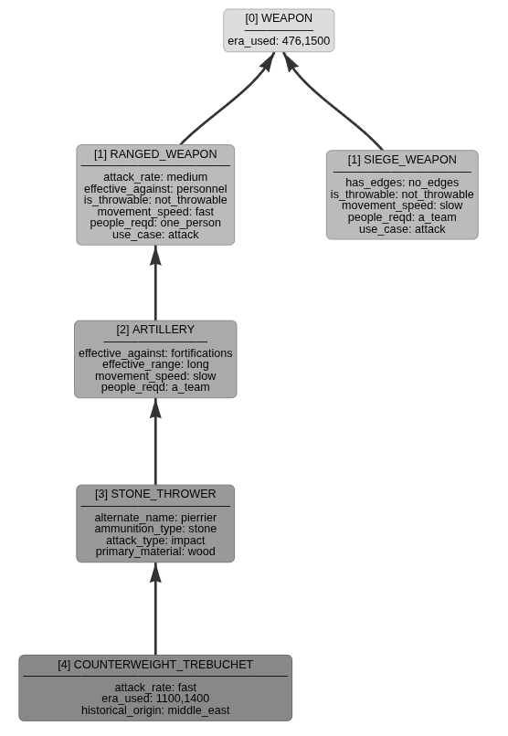
Figure 1 Showing the tree with the Trebuchet as a Ranged Weapon.

Inheritance
My design uses a strict tree without multiple inheritance. This is known as a mono-hierarchy. To fully capture the trebuchet, the tree would have to be modified allowing a single node to inherit properties from multiple parents. This highlights the difference between the simplicity of a tree and the enhanced representation allowed for by a poly-hierarchical multi-inheritance approach implemented as a Directed Acyclic Graph (DAG).

To ensure historical accuracy, the specific attributes and properties assigned to individual weapon nodes were taken from various resources, including John McDonald’s 2015 website ‘Medieval Weapons & Armour’, Charles Boutell’s book from 1893 ‘Arms and Armour’ and the Metropolitan Museum of Art’s 1991 ‘survey of arms and armour’. This research aims to provide a plausible foundation to the network.

Task 2: Semantic Network Implementation
The network was implemented in both Prolog and Python.

Python Implementation
A python class was created to allow a user to model any generic semantic network. It allows the user to add nodes and edges to the graph as ‘is_a’ and ‘has_a’ relationships. This approach represents the knowledge in the network as high-level human readable symbol, rather than numerical weights. This allows for explicit knowledge representation. (Russell 2022).

From the resulting network, the user can output the network into JSON, CSV and Prolog files. The class can also create interactive graphical visualisations which was the primary reason for implementing in python.

As the network is sizeable, containing 84 ‘is_a’ relationships and 341 ‘has_a’ properties, output visualisations are too detailed to display in their entirety in this report. They can be viewed here:

Visualisation Type | URL
Hierarchical Tree | https://datascience.daemonchild.com/year3/dat6002/Medieval_Weapons_Hierarchy.html
Network Node Diagram | https://datascience.daemonchild.com/year3/dat6002/Medieval_Weapons_Node_Diagram.html

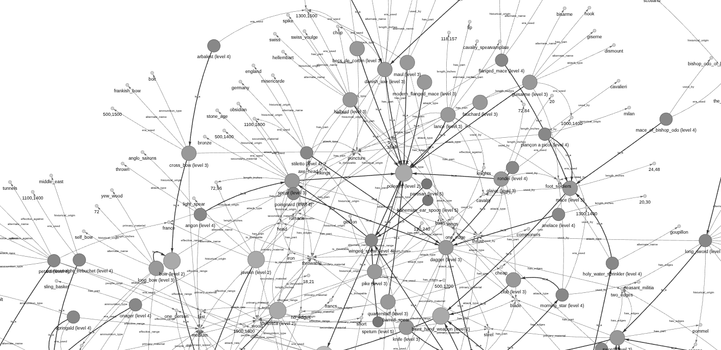
The implementation creates network node diagrams and hierarchical tree diagrams, including filtered versions that include only selected nodes (as have been used elsewhere in this report).
Figure 2 Showing a small part of a node-based visualisation.

There were several challenges in writing the python implementation. The NetworkX library is used to implement the underlying graph storage, storing items as nodes and relationships as labelled edges. It does not natively make a distinction between ‘is_a’ and ‘has_a’ edges. The ‘get_node_level’ function calculates the ‘distance’ from the root using a sub-graph structure. It was written to avoid the network taking shortcuts via ‘has_a’ edges, and only to traverse ‘is_a’ paths.

Another challenge was working with the model parameters of the PyVis library to ensure that the visualisations show the appropriate data as required and look appealing.

Prolog Implementation
The python class does not provide an inference engine, so the network is written out to a Prolog file.

In Prolog the network is implemented using two types of fact:

- is_a facts
- has_a facts

The relationships between items in the network are defined in a parent-child hierarchy using the predicate ‘is_a’. This builds a tree of relationships in the form is_a ( child, parent ).

is_a( melee_weapon, weapon ).
is_a( bladed_hand_weapon, melee_weapon ).
is_a( sword, bladed_hand_weapon ).

The properties of an object are defined as ‘has_a’ facts:

has_a( melee_weapon, effective_against, personnel ).
has_a( bladed_hand_weapon, effective_range, close_quarters ).
has_a( sword, has_part, blade ).
has_a( sword, has_part, hilt ).
has_a( sword, has_part, pommel ).

By defining nodes such as 'bladed_hand_weapon', the network utilises shared inheritance. Each class below this, for example ‘sword’, automatically inherits properties like 'effective range'. Querying the network for the unique attributes defined for a generic sword would therefore return the following, with the attributes being inherited from further up the tree:

- has_part (from sword)
- effective_range (from blade_hand_weapon)
- effective_against (from melee_weapon)

The Closed World Assumption (CWA) is a fundamental tenet of Prolog. Under CWA any statement that cannot be proven true within the knowledge-base is assumed to be false. For example: has_a (sword, colour, pink) is not specifically stated, and cannot be inherited from a parent, so Prolog will conclude that this is false. Taking this further, the inference engine utilises the Negation as Failure (NAF) principle. If the system attempts to prove a sword is pink and finds no supporting evidence the proof fails, and the statement is treated as logically false. (Clark 1978)

The CWA also ensures that the Prolog inference engine operates within a defined plausible version of reality. While other facts may be possible – such as a pink sword – the model is unable to hallucinate anything beyond the defined network. While it is physically possible for a medieval sword to have been forged from copper or decorated in pink, such facts are not plausible within the boundaries of this specific semantic network knowledgebase.

This has the disadvantage that the model also cannot make new leaps of understanding outside of its knowledgebase.

In addition to the facts, rules have been written for querying this network. Most of these functions are generic and work for any suitably defined semantic network.

- is_a_member - check class/parent membership
- has_a_property - does the item have a property?
- list_all_items - list all the items in the network (pretty output)
- get_all_items - get all the items in the network into sorted list
- list_all_attributes - list all the attributes in the network (pretty output)
- get_all_attributes - get all the attributes in the network into sorted list
- list_properties - list the defined properties for an item (including inherited)
- list_items_with_property - list all items that have a specific property-value pair (pretty output)
- show_tree - list items in an attractive tree

The following functions are specific to medieval weaponry:

- longer_range - compares two weapons for range
- list_weapons_by_year - find all weapons in use in a specific year

The Prolog inference engine uses primarily deductive reasoning, where specific conclusions (that ‘the_wallace_sword’ is a melee weapon) are derived only from the supplied facts and rules. In deduction, if the premises are true, the conclusion must also be true. (Russell 2022).

The current system does not perform inductive reasoning, which would involve the system generating its own general rules based on specific observations. For example: “I have observed several swords that were made of steel, therefore all swords are made of steel.”
Prolog also does not perform abductive reasoning, which aims to find the most likely explanation for an incomplete set of observations.

Sample Queries
The following queries were run under SWI Prolog version 9.0.4 on Linux.
It is always possible for Prolog to answer questions about the facts directly, for example:
is_a(sword, ranged_weapon) which is false.

Using the rules network can also answer questions about parent relationships. The following examples ask the question “Is a long sword a melee weapon?”, and asks Prolog to show the lineage of a long sword:

? is_a_member(long_sword, melee_weapon).
true .

?- is_a_member(long_sword, W).
W = sword ;
W = bladed_hand_weapon ;
W = melee_weapon ;
W = weapon ;

The same concept works for properties. This example shows the properties of the sword class, firstly using the raw facts (no inheritance), and secondly using the has_a_property rule to also obtain inherited properties from further up the tree, as also shown in the diagram.

?- has_a(sword, Property, Value).
Property = has_edges,
Value = two_edges ;
Property = has_part,
Value = blade ;
Property = has_part,
Value = hilt ;
Property = has_part,
Value = pommel ;
Property = primary_material,
Value = steel.

[INSERT TRACE!]

?- has_a_property(sword, Property, Value).
Property = has_edges,
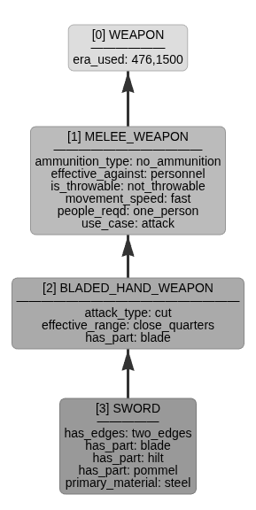
Value = two_edges ;
Property = has_part,
Value = blade ;
Property = has_part,
Value = hilt ;
Property = has_part,
Value = pommel ;
Property = primary_material,
Value = steel ;
Property = attack_type,
Value = cut ;
Property = effective_range,
Value = close_quarters ;
Property = ammunition_type,
Value = no_ammunition ;
Property = effective_against,
Value = personnel ;
Property = is_throwable,
Value = not_throwable ;
Property = movement_speed,
Value = fast ;
Property = people_reqd,
Value = one_person ;
Property = use_case,
Value = attack ;
Property = era_used,
Value = (476, 1500) ;

My list_properties rule acts as a wrapper to make the same output easier to read:
?- list_properties(sword).
Properties for sword:
Figure 3 Showing properties in one branch of the tree.
----------------------------------------
- ammunition_type = no_ammunition
- attack_type = cut
- effective_against = personnel
- effective_range = close_quarters
- era_used = 476,1500
- has_edges = two_edges
- has_part = blade
- has_part = hilt
- has_part = pommel
- is_throwable = not_throwable
- movement_speed = fast
- people_reqd = one_person
- primary_material = steel
- use_case = attack

Using a specific instance of a sword shows how inheritance works when a more specific property overrides generalisations applied further up the tree. Note from the above output that the property ‘era_used’ for a sword is ‘476 to 1500’ which is inherited from the root ‘weapon’ class.

Long swords were introduced in 1250:

?- has_a_property(long_sword, era_used, When).
When = (1250, 1550)

However, the specific instance of a long sword belonging to William Wallace has a more specific use date:

?- has_a_property(the_wallace_sword, era_used, When).
When = 1298 ;

When all the properties for The Wallace Sword are listed, the more specific date overrides both the value for era_used applied at the root of the tree and that applied to all long swords. This list shows a mixture of local, inherited and overridden properties, including the era_used property:

?- list_properties(the_wallace_sword).
Properties for the_wallace_sword:
----------------------------------------
- alternate_name = bastard_sword
- alternate_name = great_sword
- alternate_name = hand_and_a_half_sword
- ammunition_type = no_ammunition
- attack_type = thrust
- effective_against = personnel
- effective_range = close_quarters
- era_used = 1298
- has_edges = two_edges
- has_part = fullers_aka_blood_grooves
- historical_origin = scotland
- is_throwable = not_throwable
- length_inches = 40,48
- movement_speed = fast
- people_reqd = one_person
- primary_material = steel
- use_case = attack
- used_by = william_wallace
- weight_kg = 2.7

The underlying has_a_property rule implements recursive inheritance with local overrides. The cut operator (\+) is used to stop general properties from being included when a more specific instance is available.

Property overrides demonstrate the difference between monotonic and non-monotonic logic. Traditional logic is monotonic, where the addition of new facts cannot invalidate previously held truths. However, the inclusion of property overrides introduces non-monotonic behaviour. When the specific era for the Wallace sword is defined as 1298, it supersedes the inherited date from the sword class. This allows the network to handle specific exceptions without undermining the general rules of network inheritance.

It is also possible to ask some specific questions of the network using rules like longer_range:

?- has_a(biological_weapon, effective_range, Value).
Value = long.

?- has_a(long_bow, effective_range, Value).
Value = long.

?- has_a(dagger, effective_range, Value).
Value = close_quarters.

?- longer_range(long_bow, biological_weapon).
false .

?- longer_range(long_bow, dagger).
true .

As the effective_range property is a linguistic variable rather than a numerical value, the following weighting facts were used to convert to numbers and allow direct comparison in the longer_range rule. The specific values do not matter as this is only to allow comparison of these terms.

% Higher number = longer range
range_to_weight(long, 3).
range_to_weight(medium, 2).
range_to_weight(short, 1).
range_to_weight(close_quarters, 0).

One final example shows the output of the show_tree rule, which gives each of the weapons and their level in the hierarchy:
?- show_tree(weapon).
-- weapon (0)
-- melee_weapon (1)
-- bladed_hand_weapon (2)
-- dagger (3)
-- anelace (4)
-- poingnard (4)
-- rondel (4)
-- stiletto (4)
-- knife (3)
-- sword (3)
-- arming_sword (4)
-- almace (5)
-- broad_sword (4)
-- falchion (4)
-- cleaver_falchion (5)
-- cusped_falchion (5)
-- medici_falchion (5)
-- long_sword (4)
-- the_wallace_sword (5)
-- blunt_hand_weapon (2)
-- club (3)
-- morning_star (4)
-- wallace_collection_morning_star (5)
-- mace (3)
-- flanged_mace (4)
-- holy_water_sprinkler (4)
-- royal_armouries_holy_water_sprinkler (5)
-- plançon_a_picot (4)
-- mace_of_bishop_odo (4)
-- flail (3)
-- horsemans_pick (3)
-- polearm (2)
-- becs_de_corbin (3)
-- danish_axe (3)
-- pollaxe (4)
-- bardiche (5)
-- sparth (4)
-- fauchard (3)
-- glaive (3)
-- guisarme (3)
-- halberd (3)
-- lance (3)
-- maul (3)
-- modern_flanged_mace (3)
-- pike (3)
-- quarterstaff (3)
-- spear (3)
-- winged_spear (4)
-- bohemian_ear_spoon (5)
-- spetum (5)
-- corsque (5)
-- ranseur (6)
-- partisan (5)
-- angon (4)
-- ranged_weapon (1)
-- artillery (2)
-- cannon (3)
-- bombard (4)
-- petard (4)
-- stone_thrower (3)
-- ballista (4)
-- counterweight_trebuchet (4)
-- mangonel (4)
-- onager (4)
-- springald (4)
-- traction_trebuchet (4)
-- bow (2)
-- cross_bow (3)
-- arbalest (4)
-- long_bow (3)
-- francisca (2)
-- gun (2)
-- arquebus (3)
-- musket (4)
-- cavalier (4)
-- hand_cannon (3)
-- javelin (2)
-- siege_weapon (1)
-- battering_ram (2)
-- biological_weapon (2)
-- chemical_weapon (2)
-- psychological_weapon (2)
-- moveable_structure (2)
-- cat_and_weasel (3)
-- siege_tower (3)

Ethical Considerations
The network design considerations made for this project would be valid for most subject matter. The implementation in both python and Prolog languages has been made in as generic manner as possible. This would have allowed for almost any subject to have been used to give example to the construction of a semantic network.
While there is nothing inherently malicious about using historic articles of warfare as an example, there are some ethical considerations regarding the use of a medieval weaponry dataset to study semantic networks and programming in Prolog. Switching to non-violent objects can make the study of computer science feel more welcoming to those who might otherwise feel alienated or intimidated by this dataset.
Historical sources like the Metropolitan Museum of Art (1991) treat these items as artefacts of technical and cultural evolution. Humans can understand the historical context of this dataset, whereas AI systems do not have this distinction, and may struggle to give adequate weighting to non-aggressive features. Moreover, if an AI agent were to use this network as a knowledgebase to solve a problem, it is unlikely to have the human-level understanding that a particularly attractive item is a museum piece!
Furthermore, if the output of this exercise were to be fed into connectionist neural network models, there is a danger that the system may learn bias in the system, such as predicting or advocating violence based on properties such as 'causes_damage'. Worse, there is a risk that this aggression might be internalised by the neural network in a ‘black-box’ manner making such bias harder to detect and mitigate.

Part 2: Connectionist Methods
In 1943, Warren McCulloch and Walter Pitts proposed that the brain works like a series of logic gates (0’s and 1’s). They proved that neural activity is a biological way of doing maths. Modelling this behaviour in a digital neural network is a well-known problem-solving approach. In this section, I will discuss the creation and performance of several neural networks aiming to help ‘a bank’ determine which customers to call with a view to making a deposit with the bank.

Dataset Preparation
The UCI ‘Bank Full Dataset’ is related to the phone based direct marketing campaigns of a Portuguese bank from May 2008 to November 2010. Often, more than one contact to the same client was required to assess if the individual would be a subscriber to the deposit product or not. (Moro 2014)

The dataset includes 17 inputs, ordered by date and contains just over 45,000 rows. The classification goal of my Multi-Layer Perceptron (MLP) is to predict if the client will subscribe or not.

Exploratory Data Analysis (EDA) was carried out, and the dataset was audited for quality and consistency. There is not scope in this report to discuss every feature, although all were considered individually during this phase, as the accompanying Jupyter notebook attests. A variety of techniques were required to prepare the broad range of data in the dataset.

A Biased Dataset
Exploring the target dependent variable 'y' (Figure 4) shows that there is considerable bias in the dataset. While the success rate is actually very good for a cold calling telephone marketing campaign (Cognism 2025), most people did not deposit funds.

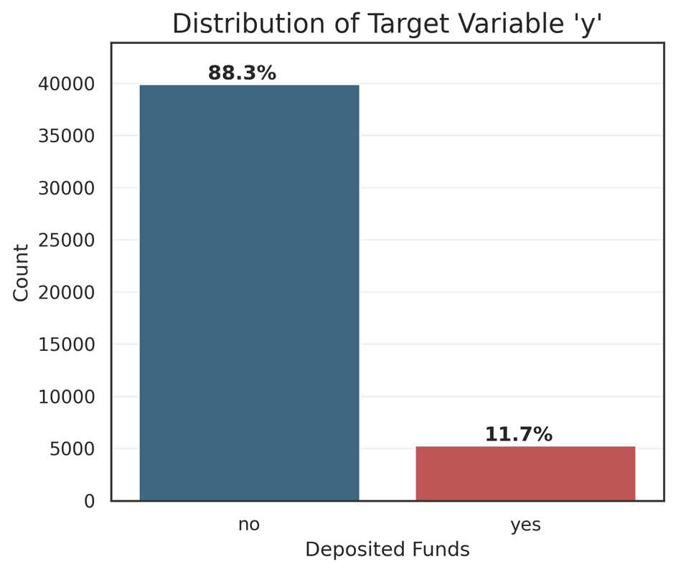
Figure 4 Showing that the dataset is highly biased towards negative results.

This bias causes issues for the neural network because the weights will tend to shift to favour negative responses; there are not many instances of positive responses to learn from. The network is likely to learn to predict ‘no’ whatever the input because this is most often correct.

Each of the other features was assessed individually to determine whether it would be useful or potentially derogatory to the performance of the MLP.

Outliers
Four features that were likely to contain outliers and/or very wide distributions: age, balance, campaign and previous [number of times contacted].

Age

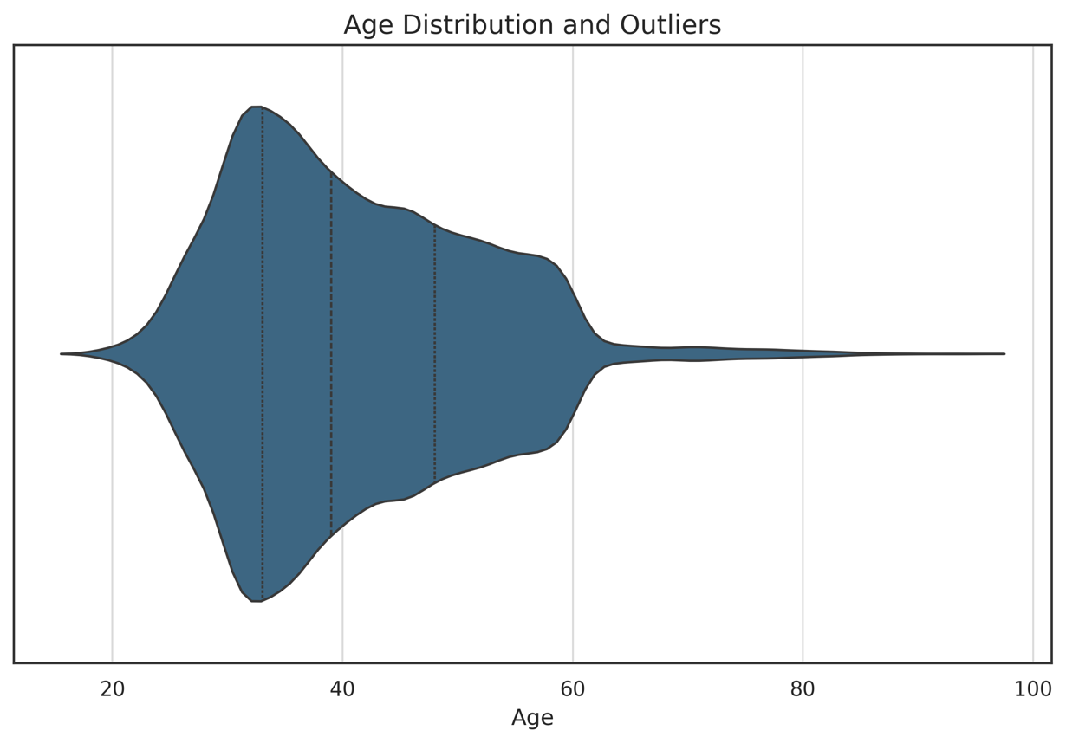
Figure 5 Violin plot for age, showing distribution and outliers
The plot shows a massive bulge between 30 and 45. This is expected and is the target audience for the bank's marketing department. The tail shows the older outliers who are people over 65-70 years old.

Standardised Z-Score Scaler was used to encode all the features with outliers, as described below.

Education
While the dataset is largely complete, there are several features where there are ‘unknown’ values. These were identified and handled as behavioural categories.

The unknown group in the education feature had a success rate of 13.6%, which is higher than the dataset average (11.7%). Thus, unknown was treated as a specific feature rather than being dropped. It was mapped to sit between secondary and tertiary education, preserving the ordinal meaning of educational progression. A numeric version of the feature was engineered to allow scaling.

Contact Type
The contact feature relates to the type of medium used to contact the individual.

This is either landline telephone, cellular phone or unknown. Today, mobile communication is most prevalent for all, with a landline possibly indicating an older person; this was not true in 2010. Since there is a significant group of unknown values, using one-hot encoding allows the model to learn their unique signature without my needing to guess if they ‘should have been’ cellular or landline contacts.

Pdays – Days Since Previous Contact
The pdays feature required special consideration. People who have never been called before are represented as -1, while the rest of the data shows how long it has been since they were contacted previously. The uncontacted make up most of the data:

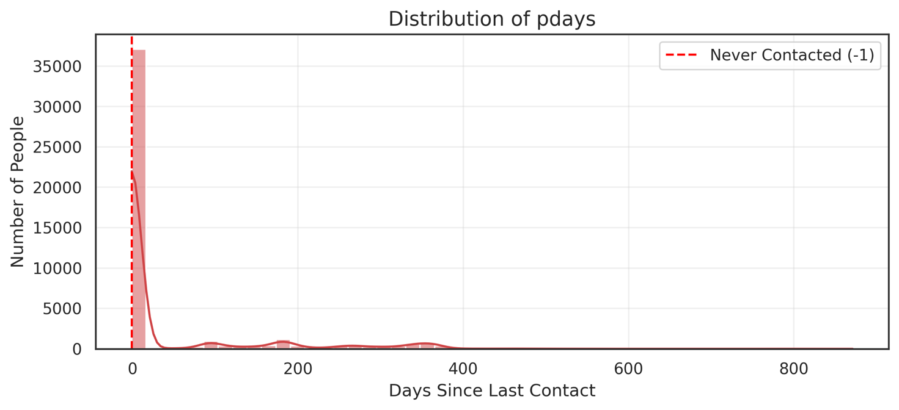
Figure 6 Showing how most of the data relates to the uncontacted.

When the -1 values are filtered out, the pdays distribution is multi-modal, exhibiting several local maxima. There are peaks at approximately 100, 180, 275 and 365 days. This suggests a re-engagement strategy based on quarterly cycles.

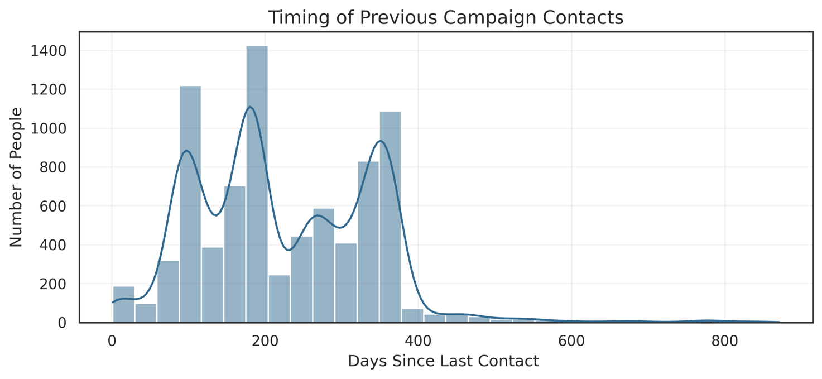
Figure 7 Distribution of filtered pdays feature (-1 removed)

To ensure the MLP captures these specific windows of time, I used a binning strategy based around these values:

Bin Value | Range
0 | -1 (never Contacted)
1 | < 30 days
2 | < 150 days
3 | < 250
4 | Longer term

Previous Outcome
It makes sense that the ‘previous outcome’ feature would likely be a useful indicator for predicting the future outcome.

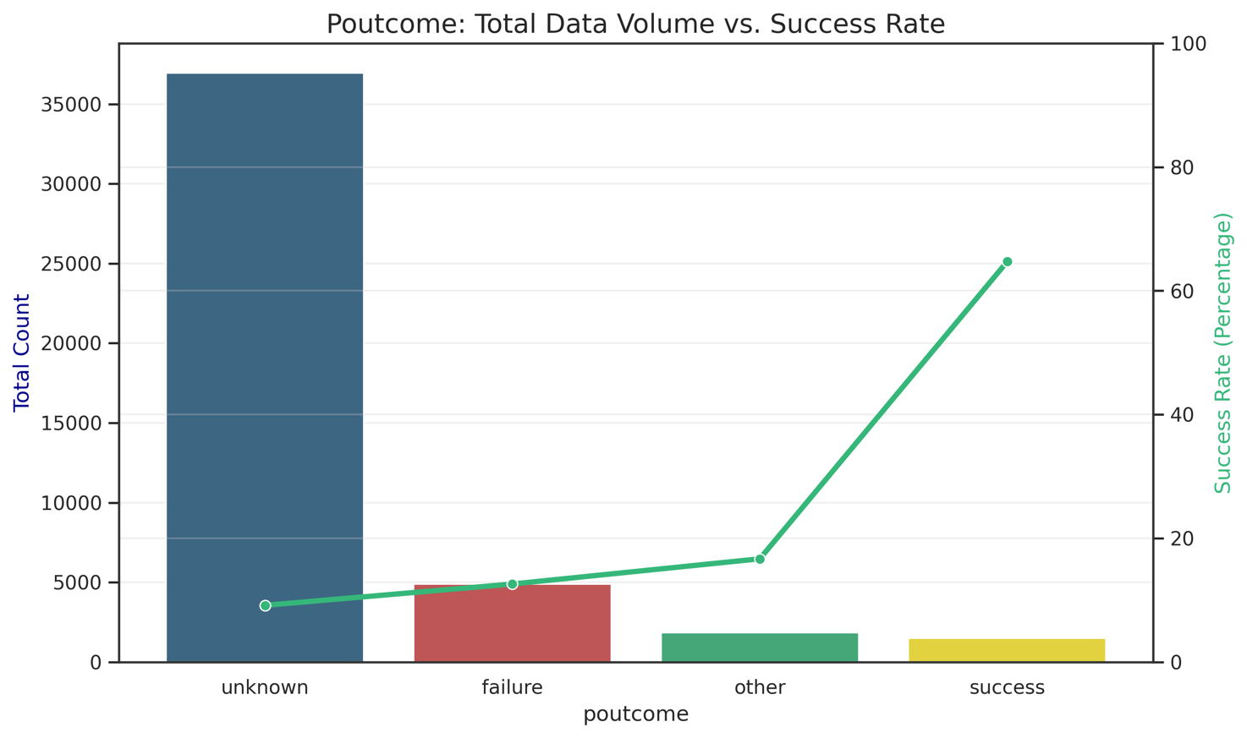
Figure 8 Exploring previous outcome

The graph shows that there is a massive disparity in the results, and if an individual said ‘yes’ last time, they are overwhelmingly likely to say ‘yes’ again.

One Hot Encoding would allow the MLP to determine for itself that the previous outcome is an excellent indicator. However, as the number of unknowns is very high in comparison, there is a strong chance that the MLP might miss these relatively rare signals of success. This may be made worse as they are distributed across training, validation and test sets.

To assist the MLP in spotting these rare but strong indicators, I used a map to manually weight these values highly to reflect their importance:

Value | Weighted Map
Success | 7
Other | 2
Failure | 0
Unknown | 1

Encoding and Scaling
All features were encoded as numeric values and scaled to give small floating-point values, generally between -1.0 and 1.0, depending on the encoding method used.
This table shows how each included feature was handled.

Encoding | Features
Binary | ‘housing', 'loan', 'y'
Z-Score Standardisation | ‘age', 'balance', 'campaign', 'previous'
Min-Max Scaling | 'pdays_binned','month_numeric','education_numeric', 'poutcome_numeric’
One Hot Encoding | 'job', 'marital', 'contact'

One-Hot Encoding
The non-ordinal categorical features were expanded using One Hot Encoding. This prevented the model from assuming a false linear relationship between unrelated categories for example "Single" vs. "Married". There is no "ascending" or "descending" order that matches such status categories, and there is no hidden meaning in the order of this data. One-hot encoding allows the MLP to treat each status as a unique binary value.

Binary Variable Encoding
Binary features were simply encoded as ‘yes’ = 1.0 and ‘no’ = 0.0.

Normalisation Functions
Z-Score Standardisation was applied to features with significant outliers, such as balance and campaign because this centres the values around 0 as the mean. The standard deviation is used to calculate the spread of values.

The function for this operation is: $x_{scaled}=\frac{x-μ}{σ}$

Min-Max Scaling was used for other numeric features to squash values into a 0 to 1 range.

The function is: $x_{scaled}=\frac{x-min⁡(x)}{max\left(x\right)-min\left(x\right)}$

Removal of Problematic Features
Several features were removed from the model. The ‘duration’ feature is the most interesting problematic feature because as well as being highly skewed by outliers, it also allows for data leakage ‘from the future’ into the model.

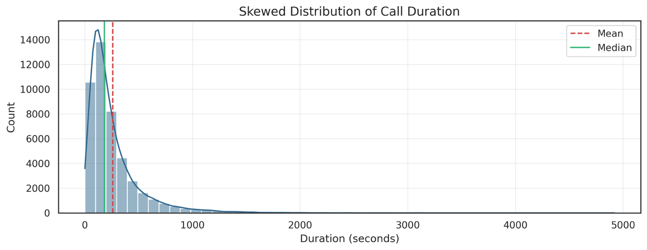
Figure 9 Exploring duration

If a person talks for 30 minutes, they have almost certainly already said "Yes". Conversely, if they end the call after a very short time, then they are likely to have said "No". The longer duration is a result of positive intent, not a cause.

The purpose of the MLP is to assist the bank to decide who to call tomorrow based on known data. Since they haven't called yet, they have no "duration" value to give the model. The duration only becomes known after the decision has already been made, and the target value for 'y' is known. Therefore, including it would poison the model outcome.

Other features were also dropped for the following reasons:

Feature | Action | Reasoning
Duration | Dropped | Target leakage; duration is not known at the time of prediction.
Default | Dropped | Near-zero variance; 98% of entries are 'no'.
Day | Dropped | Does not appear to add value; no obvious trends.
Pdays | Binned Version Kept | Re-encoded to handle multi-modal distribution and -1 values.
Month | Encoded version kept | Re-encoded as values 1-12
Education | Encoded version kept | Re-encoded as values 0-3
Poutcome | Encoded version kept | Re-encoded as values 0-7

Correlation with Dependent Variable ‘y’
The remaining features in the dataset were compared with the target variable ‘y’ to show which features have the best correlation. I would expect these features to correspond to strong indicators for the MLP to learn from.
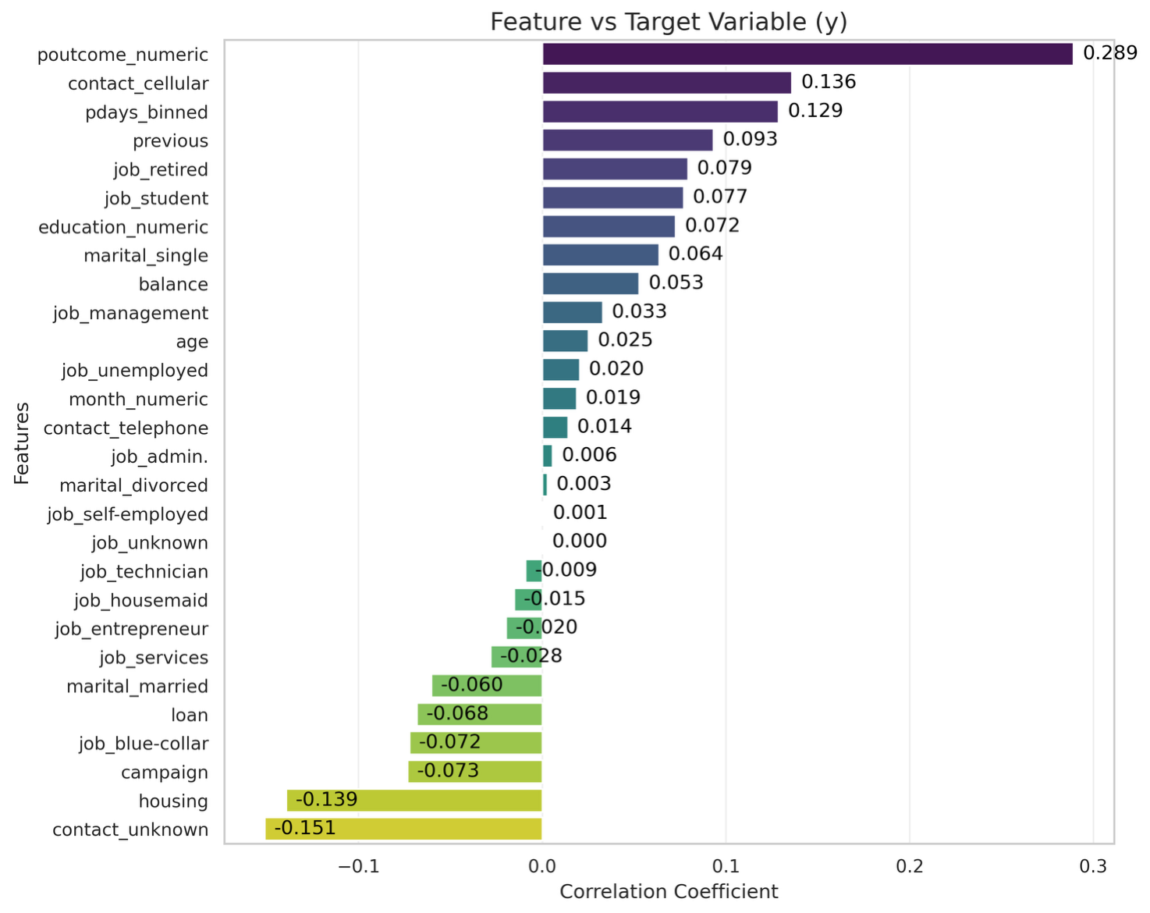
Figure 10 Correlation of features vs 'y'
Strongest Positive Correlation: poutcome_numeric (0.289), contact_cellular (0.136) and pdays_binned (0.129). The previous outcome was already shown to be a strong indicator but contact by cellular phone is a slight surprise.
Demographics: job_retired, job_student, and marital_single are all positively correlated with success. This confirms that specific life stages are more likely to say "yes". Students, for example, are likely planning for their future and trying to make savings, while the retired likely have spare cash to invest.
Weak correlation: The balance (0.053) correlation is weaker than might be expected, meaning it is not the primary driver for a ‘yes’ result in this campaign.

Post Processing
After preprocessing, the dataset was written out to a new CSV file to allow the same data to be used in both the MLP written ‘from scratch’ and the MLP based on Scikit-Learn Python libraries.

Before loading the data into either MLP implementation, one further step was required: splitting the dataset into training, validation and testing data. The data was split 80% towards the training data, with 20% going to form the test dataset. The training data was split further, again 80:20, into training and validation sets.

The dataset is date ordered, meaning that it must be shuffled to avoid the MLP learning patterns based on the sequence of the rows, such as time-of-year trends.

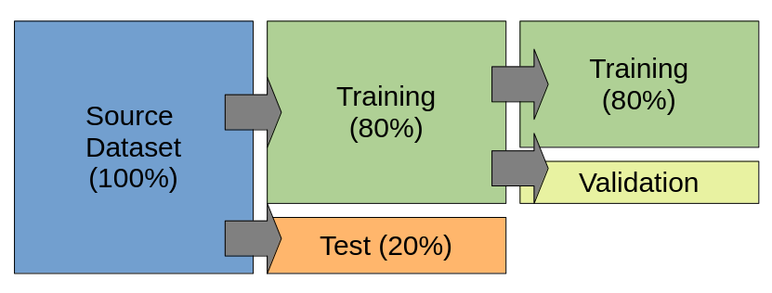
Figure 11 Training, validation and test data splitting method.

Furthermore, ‘stratified sampling’ of the success and failure classes means that the target variable imbalance (88.3% vs 11.7%) was preserved across the training, validation and testing datasets. This prevents the result from being skewed by a disproportionate distribution of target variables in these datasets.

In the instance of the ‘from scratch’ MLP, this was done using a custom python function, whereas splitting the data for the Scikit-Learn based MLP utilised the ‘train_test_split’ function with the stratify and shuffle parameters enabled.

Implementation of ANN From Scratch
The ‘from scratch’ MLP was implemented in Python as a Class ‘MLP_From_Scratch’. It provides several public functions:

Function | Purpose
Class Constructor | Creates new network using provided training and test datasets, automatically splitting out validation data. The number of input neurons is determined by the input dataset.  Allows user to tune parameters:  - no_hidden_neurons  - no_output_neurons  - output_threshold  - validation_split (%)
train_network | Performs network training for a user supplied number of epochs. Allows user to define learning_rate.  Steps:  - Feed Forward  - Back Propagation (Output Layer)  - Back Propagation (Hidden Layer)  - Weights and biases updated
evaluate | Return accuracy.
plot_error | Plots the training and validation set losses for comparison.
plot_confusion_matrix | Plots a graphical confusion matrix.
print_confusion_matrix | Prints a text representation of the confusion matrix.
save_weights | Save out the weights and biases for future use.
load_weights | Load in a set of saved weights.
get_report | Print a report of model accuracy, recall, precision and F1-score.
set_model_parameters | Allows user to reset learning_rate and output_threshold hyper-parameters.

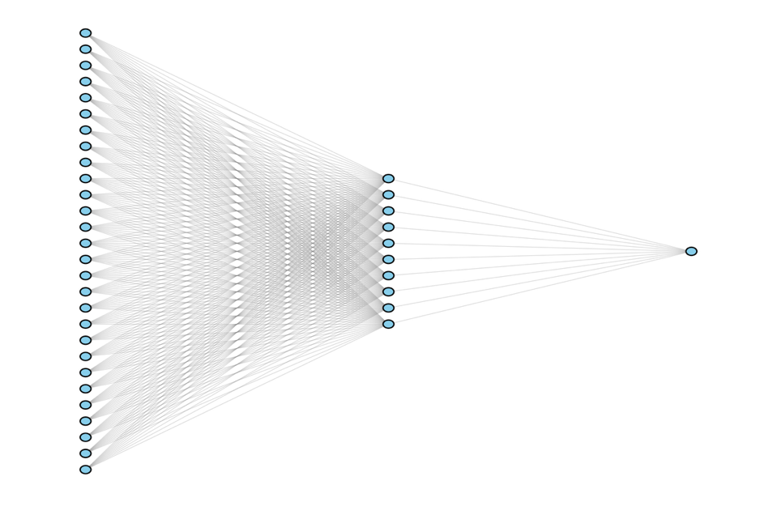
Network Architecture
Figure 12 Neural network architecture
After encoding, the input layer consists of N=28 neurons. The hidden layer is explicitly defined as 10 neurons.

As this is a binary classification, the output layer consists of 1 neuron using a Sigmoid activation function, outputting a probability score.

Feed Forward Pass
The forward pass is simply computing the dot product of weights and inputs, plus the biases
$$Z=w.x+b$$

and then applying activation functions at the hidden and output layers.

The ReLU (Rectified Linear Unit) function is used in the hidden layer. Initially, I was using the Sigmoid function for both hidden and output layers. However, performance was improved significantly using ReLU at the hidden layer. The network likely experienced a vanishing gradient due to the limitations of the sigmoid derivative function – the weight values become very small, very quickly.

ReLU Activation Function

$$ReLU(x)=max⁡(0,x)$$

Sigmoid Activation Function
$$A=σZ$$

where sigma(x) is:
$$σ(x)=\frac{1}{1+e^{-x}}$$

The Sigmoid function is the standard choice for the output layer in a binary classification task because it squashes any input into a value between 0 and 1, which represents the probability of an individual subscribing. (Bishop 2006, pp236) The default threshold for the output later was set at >0.5 = ‘yes’.

Back Propagation
The backwards pass works by calculating the partial derivative of the loss with respect to each weight.

Loss functions are used instead of raw error because raw errors can cancel each other out. This can give the illusion of good performance even when the model is doing poorly. A proper loss function means that all mistakes to contribute to the total loss, ensuring the network gets a workable gradient to learn from.

Originally, I had used Mean Squared Error to calculate the loss in the back propagation passes. The performance of the model was poor, so I explored other options.

Mean Squared Error:
$$MSE=\frac{1}{m}\sum_{i=1}^{m}{(y^{i}-{{y^}^{i})}^{2}}$$

Binary Cross-Entropy:

$$BCE=\frac{-1}{m}\sum_{i=1}^{m}{\left[y^{i}\ln\left({y^}^{i}\right)+\left(1-y^{i}\right)ln⁡(1-{y^}^{i})\right]}$$

Following the recommendations in Bishop, the loss function was transitioned from Mean Squared Error to Binary Cross-Entropy. This gave much improved results.

MSE assumes the data follows a normal distribution, whereas BCE works with data that follows a binary output, in this case ‘yes’ or ‘no’, in a Bernoulli distribution (Deisenroth 2021). It cancels out the way the gradients become ‘flat’ with the sigmoid function and prevents the learning from slowing down over time.

Weight and Bias Update Step
The final step of the learning process is where the gradients calculated during backpropagation are used to adjust the weights and biases.

This model employs Gradient Descent, governed by the following update rules:

$$w_new = w_old - ( η · ∂L/∂w )$$
$$b_new = b_old - ( η · ∂L/∂b )$$

The ‘learning rate’ determines the step size taken toward the local minimum. In early testing, I had set the learning rate too high (0.05), which caused the error lines on the loss graph to diverge, as the updates overshot the local minima. Through experimentation, a lower rate of 0.005 was selected.

While weights determine the strength and direction of the relationship between input features and the prediction, biases provide the model with flexibility. By adding a bias, the activation function can shift its position on the graph away from the origin. This is crucial because real-world data patterns rarely start at zero; the bias allows the neural network to move its decision boundary for the specific dataset.
As only 11.7% of customers subscribed, the bias is particularly important. The bias reflects the skewed reality of the dataset. It forces the model to be pessimistic, only predicting a ‘yes’ when the evidence is overwhelmingly positive in the features.

Performance Evaluation
To monitor the model's ability to work with as-yet unseen data, the training of the model was validated every 100 epochs by using a validation dataset. This is split from the supplied training dataset automatically on model initialisation.

The validation set was used to monitor the performance during training, or to adjust the number of epochs or which learning rate to use. The Binary Cross-Entropy loss was calculated for both the training and validation subsets.

Using the test dataset at this stage would be leaking information into the training process. The system may end up with a model that performs well on that specific test data but then fails in the real world. Using a separate validation set keeps the test set completely unseen until it is used in the post-training phase.

The training losses are stored and plotted on a graph after the training is completed. It is possible to see where learning stops by observing the change in the curve.

The following graph shows how the losses flatten out over 10,000 epochs after an initial steep learning period. There is little point in continuing any further as the improvements in the model over time do not justify the additional compute requirements for more training epochs.
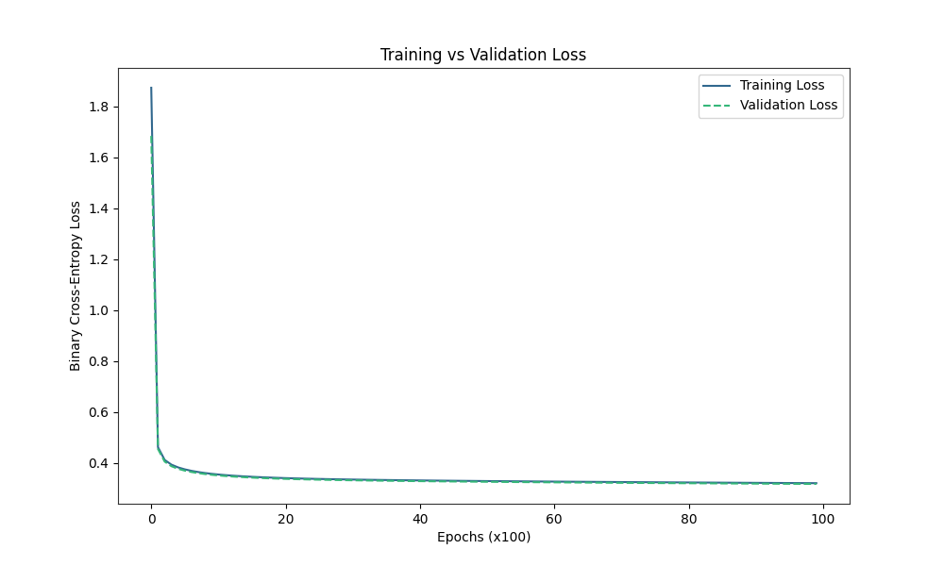
Figure 13 MLP Training vs Validation loss over 10,000 epochs

After training, a confusion matrix is drawn to show the true behaviour of the MLP at predicting against the test dataset.

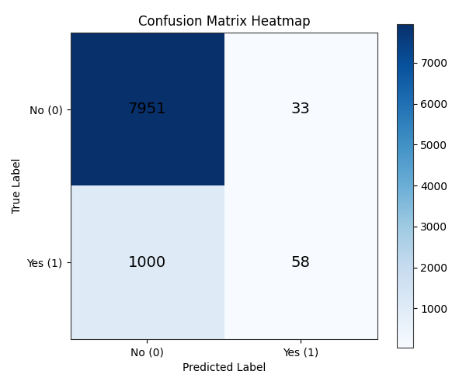
Figure 14 Confusion Matrix, Output Threshold = 0.5

True Negatives: The model is excellent at identifying people who will not subscribe. This is expected because ‘no’ is the majority class.

True Positives: The model correctly identified only 58 successful deposits.

False Positives: The model predicted a ‘yes’, but it didn't happen. This number is quite low, which means that the bank wouldn’t waste much effort if they called these people and were told ‘no’.

False Negatives: There were 1000 people who said ‘yes’ but the model predicted they would say ‘no’, meaning that the bank would be unlikely to expend the effort to call them. This would mean that the bank missed out on many deposits.

Using the above values, the following metrics were calculated:

Metric | Score | %
Accuracy | 0.8858 | 88.6%
Precision | 0.6374 | 63.7%
Recall | 0.0548 | 5.5%
F1-Score | 0.1010 | 10%

Metric | Mathematical Formula | Description | What it tells the Bank
Accuracy | $$\frac{TP+TN}{TP+TN+FP+FN}$$ | The proportion of total predictions that were correct. | Overall success rate.
Precision | $$\frac{TP}{TP+FP}$$ | The proportion of positive identifications that were correct. | When we call someone a potential customer, how often are we right?
Recall | $$\frac{TP}{TP+FN}$$ | The proportion of actual positives that were identified correctly. | Out of everyone who would have said 'Yes', how many did we find?
F1-Score | $$2.\frac{Precision.Recall}{Precision+Recall}$$ | The mean of Precision and Recall. | The balanced score.

The confusion matrix reveals that while the MLP achieves a high accuracy of 88.6%, it suffers from a significant number of False Negatives. The model is heavily biased toward the majority class 'no', resulting in a very low recall of 5.7%. This indicates that the model is predicting the most frequent outcome. This was expected and predicted during the data preparation phase.

While the bias is correctly shifting the activation function to reflect probability of the majority 'no' class, a standard 0.5 classification threshold was too high. The model was tuned using the output threshold to determine whether these scores could be improved.

The output threshold was varied from 0.0 to 1.0 in a loop, and the performance metrics calculated. These results were plotted on the following graph:

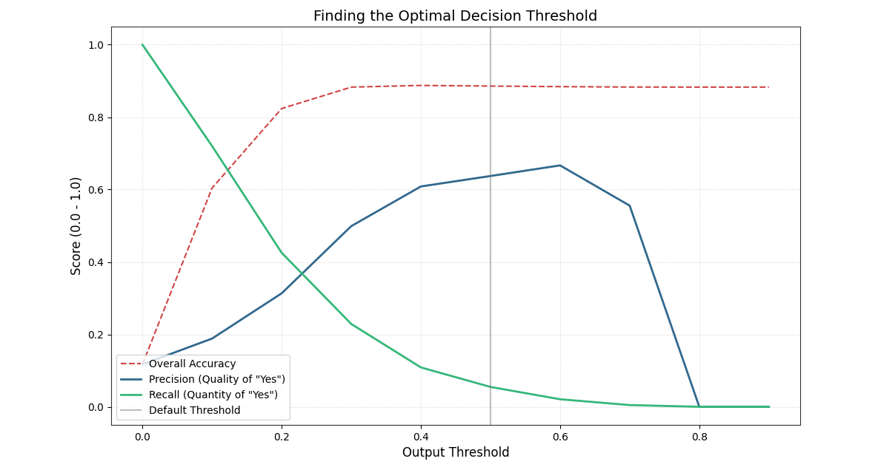
Figure 15 The cross over point of recall and precision is the best compromise.
The point at which the recall and precision lines cross gives the best trade-off between these scores. This was calculated to be 0.23. The confusion matrix for the threshold set at this value is:

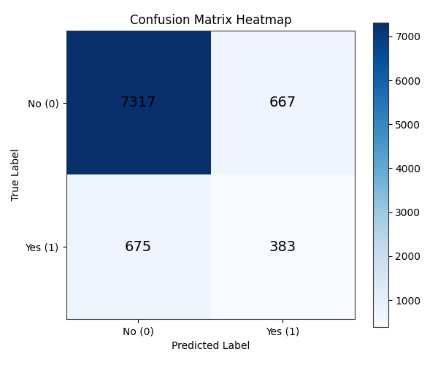
Figure 16 Confusion Matrix, Output Threshold = 0.23

This is a much more balanced result.

Metric | Score | %
Accuracy | 0.8516 | 85.1%
Precision | 0.3648 | 36.5%
Recall | 0.3620 | 36.2%
F1-Score | 0.3634 | 36.3%

Lowering the threshold seems to contradict the role of the bias but allows me to place more priority on the recall of the model. By adjusting the output threshold, the recall improved dramatically from 5.4% to 36.2%. While this resulted in a slight decrease in accuracy and precision, the model became more useful for a bank marketing campaign.

In this context, the cost of a phone call resulting in a False Positive is relatively low compared to the high value of a 'True Positive'. This ensures the bank will contact more potential customers. Adjusting the threshold is a business decision made after the models training has finished.

ANN Implementation with Libraries
An MLP was also developed using the Scikit-Learn library to act as a comparison against the ‘from scratch’ version discussed above.

Choice of Library
As before the pre-processed dataset was split 80:20 into training and test; validation being internal to the model. I used the Scikit-Learn library ‘train_test_split’ function with the stratify and shuffle parameters enabled. The Keras library does not provide functions for data manipulation, so would have either had to do this myself as before, or use the Scikit-Learn library anyway.

I also chose to use Scikit-Learn rather than Keras because the dataset is only moderately sized. Once engineered, it has 28 input features and around 45,000 rows. Keras is built by Google to use TensorFlow or PyTorch and is designed for large-scale deep learning projects. (Keras.io 2026)

Keras requires the user to define input shapes explicitly and needs to have access to specific back ends libraries, such as TensorFlow, which can be challenging to set up on a workstation. Scikit-Learn handles the underlying maths and provides a simple interface without needing further libraries, beyond NumPy.

Model Parameter Configuration
The MLPClassifier class was used to create the neural network.

To ensure a fair comparison, I chose parameters for the network that would be as close to the ‘from scratch’ configuration as possible:

From Scratch MLP Setting | MLPClassifier Setting
10 hidden neurons | hidden_layer_sizes = (10,)
Hidden layer activation: ReLU  Output layer activation: Sigmoid | activation = ‘relu’
Weight updates: gradient descent | Solver = ‘sdg’
Default Learning Rate = 0.005 | learning_rate_init = 0.005
Epochs = 10,000 | max_iter = 10000

This aims to ensure that comparison between the models will be based on the implementation, rather than the underlying mathematical functions in use.

Performance Comparison
As before, a confusion matrix was drawn to show the true behaviour of the MLP at predicting against the test dataset. The test dataset accounts for 9043 people:

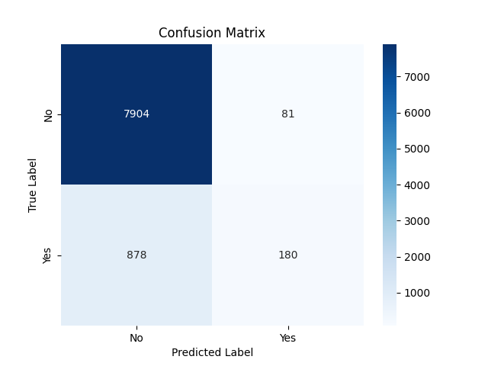
Figure 17 Confusion Matrix, SKL implementation

The performance of the library-based model was much better than the base ‘from scratch’ MLP in several ways:

 | From Scratch, TH=0.5 | From Scratch, TH=0.23 | SKL MLP
True Negatives (TN) | 7,951 | 7,317 | 7,904
True Positives (TP) | 58 | 383 | 180
False Positives (FP) | 33 | 675 | 81
False Negatives (FN) | 1000 | 667 | 878

In both implementations, the number of both true and false negatives was high. This was expected due to the skewed nature of the input dataset.
The TH=0.5 ‘from scratch’ model is very conservative, predicting ‘no’ in most cases. The number of False Positives is very low, so when it does predict a ‘yes’ you can usually believe it. It misses nearly everyone else, however!
The TH=0.23 model is much better as a marketing tool. It prioritises differently, allowing it to catch many more positive results. This has come at the cost of a large increase is False Positives. As mentioned previously, the cost to the bank of calling these people once anyway is low. While there would be more people who say ‘no’, the number of deposits made would be significantly higher.
The SKL model has much better internal optimisation. It found more True Positives than the TH=0.5 model and also has a low False Positive rate. The ‘from scratch’ models took around a minute of CPU time to train; SKL took only 3 seconds to completely reach this level of prowess. It implements an ‘early stopping’ monitor meaning that 10,000 epochs weren’t needed either. It would likely achieve even better results if tuned to the same 0.23 threshold as the ‘from scratch’ version.
Metric | From Scratch, TH=0.5 | From Scratch, TH=0.23 | SKL MLP
Accuracy | 88.58% | 85.16% | 89.35%
Recall | 5.48% | 36.48% | 17.49%
Precision | 63.74% | 36.20% | 67.03%
F1-Score | 10.09% | 36.34% | 27.74%

The SKL MLP achieved the highest overall accuracy. However, in the business context of the dataset, accuracy is not the correct metric to use alone. Even though the SKL model is more accurate it still misses 878 potential subscribers.
The TH=0.23 model is the clear winner wither respect to the bank’s marketing requirements. It improved the Recall Score from a terrible 5.48% to a winning 36.48%. This represents an increase of around 6.5 times in the number of successful responses.
The SKL MLP has the best Precision, meaning the "yes" predictions are the most reliable. However, the cost of calling a customer who says "no" (a False Positive) is generally much lower than the value of missing a customer who would have said "yes", so it is not the best model from this perspective.

Advantages and Disadvantages
One disadvantage is that the library does not expose how the validation set is composed or allow me to graph this as was possible in my own implementation. This reduces visibility of the training process. While early stopping is internally implemented, the inability to plot the validation loss does not allow for the same visual check against over fitting.

Furthermore, as well as having access to the loss calculations, I have complete control over the validation dataset in my model, allowing me to analyse it, including printing it all out if I really wanted to. I can also access the weights and biases at any given time, even during training.

Another disadvantage of the library MLPClassifier is that it includes some rigidity in the implementation. The configured activation function applies to all layers and cannot be varied across layers. Conversely, the ‘from scratch’ implementation is more modular. It allows for flexibility and experimentation with different activation functions at different levels. I used ReLU for the hidden layer and Sigmoid for the output layer, which is not possible using the library for the network.

The main disadvantage of using the ‘from scratch’ model is the length of training time. Many thousands of Python loops over matrix calculations are very slow, even though NumPy itself is highly optimised internally. The Scikit-Learn library uses C library code in the background and is highly optimised.

Writing a model from scratch gives control, while using a library provides speed, built-in optimisation and convenience. Developing the model from scratch provided transparency to monitor the impact of class imbalance in the dataset by plotting the validation loss, and by modifying output thresholds accordingly.

Parameter Tuning and Model Optimisation

GridSearchCV
A lot of the optimisation steps applied so far have been ad hoc and based on observation and educated guesses. To move beyond manual trial-and-error changes to settings, GridSearchCV from Scikit-Learn was used to systematically make changes to hyper-parameters in the SKL based model.

I have already identified that the accuracy metric is not the best for this dataset, so the optimisation target was set to Recall combatting the class imbalance in the target variable.

CV stands for Cross-Validation, which means that the data is rotated to that each row has the chance to be part of the training and validation datasets. I have used cv=3, which defines three ‘folds’ of the data. This means that the model is trained three times, using the data folds as follows:

Training | Validation
1 + 2 | 3
1 + 3 | 2
2 + 3 | 1

This method reduces any errors that might be derived from the data itself, such as the lucky inclusion of ‘easy’ rows which might contain hidden shortcuts to the target variable. An example of such a shortcut would be the duration feature, which was removed entirely during the preprocessing phase.

I defined the following grid of parameters to extensively test different model architectures, learning rates and weight/bias adjustment algorithms:

'hidden_layer_sizes': [(10,), (15,), (10, 5), (15, 5)],
'learning_rate_init': [0.001, 0.01, 0.005, 0.03, 0.05],
'max_iter': [2000, 5000, 10000, 15000, 20000],
'solver': ['sgd', 'adam', 'lbfgs', 'newton-cg']

This is an extensive search grid. To optimize the hyper-parameter search, the n_jobs parameter was set to -1 to make python use all the cores in my workstation. By distributing the Grid Search across all CPU cores, the computational time was significantly reduced. This allowed for a more exhaustive search of the parameter grid (comparing different solvers and architectures) than would have been feasible otherwise. Even so, this grid took 14 minutes to run through.

The best parameters were found to be:

'hidden_layer_sizes' = (15, 5)
'learning_rate_init' = 0.05
'max_iter'= 2000
'solver'= 'adam’

The grid search revealed that the 'Adam' optimizer and two hidden layers of 15 and 5 neurons provided a more stable descent than the model defined previously. Running the test data through the best model produces the following confusion matrix:
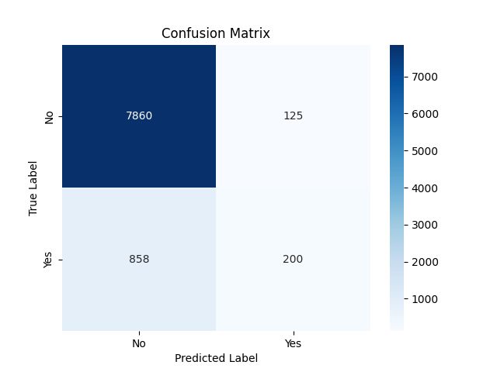
Figure 18 Confusion matrix, grid search optimised MLP

Adding these results to the table:

 | From Scratch, TH=0.5 | From Scratch, TH=0.23 | SKL MLP | Grid Optimum
True Negatives (TN) | 7,951 | 7,317 | 7,904 | 7,860
True Positives (TP) | 58 | 383 | 180 | 200
False Positives (FP) | 33 | 675 | 81 | 125
False Negatives (FN) | 1000 | 667 | 878 | 858

And the metric table is also extended:

Metric | Custom (TH=0.5) | Custom (TH=0.23) | SKL MLP | Grid Optimum
Accuracy | 88.58% | 85.16% | 89.35% | 89.13%
Recall | 5.48% | 36.48% | 17.49% | 18.90%
Precision | 63.74% | 36.20% | 67.03% | 61.54%
F1-Score | 10.09% | 36.34% | 27.74% | 28.92%

A true comparison is best made between the SKL and Grid Search optimised versions as these are based on the same underlying code. There is some improvement in the recall, but not significantly. As expected, there is a trade-off between recall and precision.

Genetic Algorithm Optimisation
I implemented a genetic algorithm version of my ‘from scratch’ MLP class code. In a standard MLP, back propagation using gradient descent and partial derivatives is used to minimise loss.

In the Genetic Algorithm (GA) version the back propagation process was removed and replaced with evolutionary operators. Rather than calculating gradients, the GA treats the neural network’s weights as a chromosome and uses the principles of natural selection to find a solution.

I implemented a genetic algorithm version of my ‘from scratch’ MLP Python Class, and some surrounding functions to run the evolutionary process. The following steps are followed to evolve the ‘best’ MLP:

- Creation of an initial population of candidate MLP objects.
- Loop through the generations.

For each generation:

- Calculate the fitness metric for individuals.
- Sort the individuals based on fitness (in descending order, highest at the top). The fitness function is simply one of the four metrics: accuracy, recall, precision or F1-Score. (Recall is used as the default as this gives the best possible outcome for true positives, but this is tuneable as needed.)
- Keep the very best individuals each time. This process is known as elitism, where the best survives regardless of their age in the population. The top-performing models are retained to prevent the loss of the highest performing traits so far.
- Cull the bottom half of the population. The culling rate variable is used to remove the bottom percentage of the population with each generation. This is set to 50% by default, leaving the top 50% of parents available to create the next generation.
- Generate new children to fill the population using crossover and possible mutation.

Crossover
Pairs of parents exchange ‘genetic material’ (their weights and biases data), combining successful patterns to create offspring. I chose to find a random point and then swap the ‘tails’ of data after that point.

Mutation
Random variations are introduced to the chromosome to mimic real life mutations, and to prevent the algorithm from getting stuck in a local minima. A mutation is only applied when a random dice roll is below the mutation rate value (this is user configurable).

To implement the chromosome, the weights and biases are flattened into a single one-dimensional array. To put this back together into arrays after crossover and mutation, I used the stored lengths of the weights and biases to chop up the chromosome.

The first run of the algorithm used the following parameters. Recall was used as the fitness function to give it the best chance of finding the True Positive responses.

Parameter | Value
Fitness Function | Recall
Population Size | 20
Generations | 20
Culling Rate (Take away bottom N%) | 50%
Elite Size (Retain top N) | 5
Mutation Rate | 0.05 (5%)

The confusion matrix for this run follows:

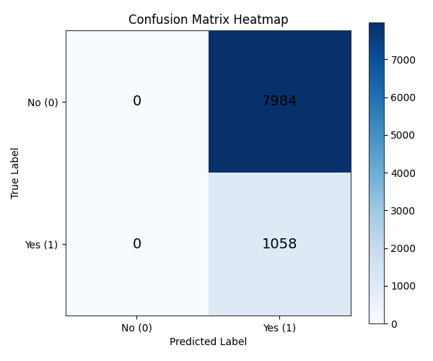
Figure 19 Showing first run of GA, using recall as fitness function

This is bad! However, this is the best score for Recall that the MLP has generated (99%). Because the fitness function told the GA to maximize recall, it learned that the way to never miss a 'yes' is to predict it for everyone. This is almost the opposite of the original ‘from scratch’ MLP which tends to predict a negative result.

A better metric to use would be the F1-Score because this is made up of both recall and precision.

Running the same parameters, but specifying the F1-Score metric as the fitness function gives the following confusion matrix:
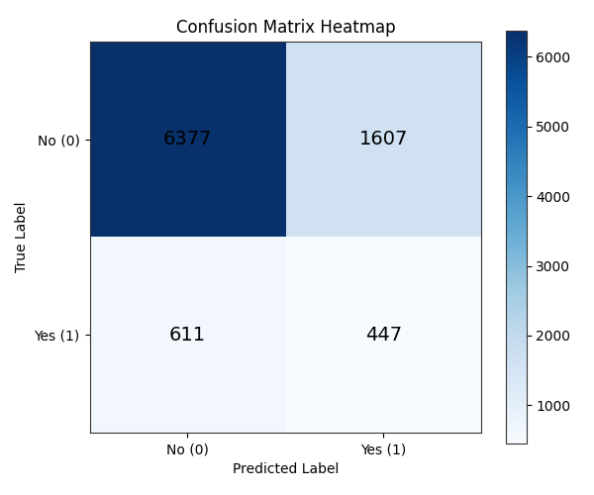
Figure 20 F1-Score GA Based MLP, 20 Generations

Metric | Score | %
Accuracy | 0.7547 | 75.5%
Precision | 0.2176 | 21.8%
Recall | 0.4225 | 42.3%
F1 Score | 0.2873 | 28.7%

The evolution loop records the number of mutations and the best fitness score for each generation. Once this has been plotted, it shows whether the volatility of the mutations results in great leaps in fitness.

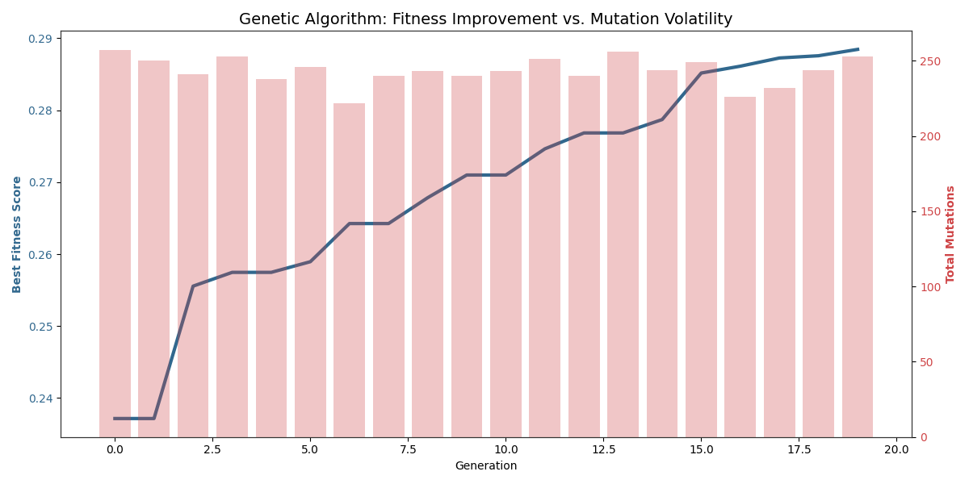
Figure 21 GA MLP, 20 generations, 0.05 Mutation Rate

I also ran the same parameters but with 200 generations and found that only small improvements were made. However, it must be remembered that the initial weights for the individual MLPs are entirely random, as are the mutations and crossovers. It is not possible to have two runs that are identical, and a subsequent run with the same parameters might give better (or worse) results.

Going back to the principles discussed by McCulloch-Pitts (1943), the genetic algorithm applies a wider search space when looking for the optimum way wire together the digital neurons in the network. The randomness in the algorithm means that it potentially tries out wildly different connection configurations rather than changing the existing one in small ways. In the context of the bank dataset, this is highly effective.

As noted in Cognism 2024 cold-calling success rates are very low. A MLP optimised using F1 Score ensures that the model is aggressive enough to identify every possible ‘yes’ even if it increases the volume of total calls. As discussed before, these extra calls are cheap compared with the loss of value to the bank from missed deposits.

References

Part 1 – Symbolic AI
- Boutell, C. (1893) Arms and Armour – In Antiquity and the Middle Ages, London: Reeves and Turner, Available at: https://archive.org/details/armsarmourinanti00laco (Accessed: 16 Feb 2026)
- Campbell, N.A. and Reece, J.B. (2005) Biology. 7th edn. Harlow: Pearson. Available at: https://cssplatformbytha.com/wp-content/uploads/2024/10/Biology-by-Neil-A.-Campbell-Jane-B.-Reece-z-lib.org_.pdf (Accessed: 14 April 2026)
- Clark, K.L. (1978) 'Negation as Failure', in Gallaire, H. and Minker, J. (eds.) Logic and Data Bases. New York: Plenum Press, pp. 293–322. Available at: https://www.doc.ic.ac.uk/~klc/NegAsFailure.pdf (Accessed :14 April 2026)
- McDonald, J. (2015) Medieval Weapons & Armour, Castles and Manor Houses Inc. Available at: https://www.medievalwarfare.info/weapons.htm (Accessed: 16 Feb 2026)
- Metropolitan Museum of Art (1991) Arms and Armor: Permanent Collection. Available at: https://resources.metmuseum.org/resources/metpublications/pdf/Arms_and_Armor_Permanent_Collection_The_Metropolitan_Museum_of_Art_Bulletin_v_49_no_1_Summer_1991.pdf (Accessed: 16 Feb 2026).
- Russell, S.J. and Norvig, P. (2022) Artificial Intelligence: A Modern Approach. 4th edn. Harlow: Pearson. Available at: http://lib.ysu.am/disciplines_bk/efdd4d1d4c2087fe1cbe03d9ced67f34.pdf (Accessed 14 April 2026)
- Study.com (n.d.) Middle Ages Events | History & Timeline. Available at: https://study.com/academy/lesson/major-events-in-the-middle-ages.html (Accessed: 18 Feb 2026).
- Wikipedia (2026) Fall of the Western Roman Empire. Available at: https://en.wikipedia.org/wiki/Fall_of_the_Western_Roman_Empire (Accessed: 18 Feb 2026).
- Wikipedia (2026) Reformation. Available at: https://en.wikipedia.org/wiki/Reformation (Accessed: 18 Feb 2026).

Part 2 – Connectionist Methods

- Bishop, C.M. (2006) Pattern Recognition and Machine Learning. New York: Springer.

- Cognism (2024) Cold calling success rates: everything you need to know. Available at: https://www.cognism.com/blog/cold-calling-success-rates (Accessed: 18 April 2026)

- Deisenroth, M., Faisal, A. A., Ong C. S. (2021) Mathematics for Machine Learning. Cambridge: Cambridge University Press

- Keras (n.d.) About Keras. Available at: https://keras.io/getting_started/about/ (Accessed: 2 May 2026)

- McCulloch, W.S. and Pitts, W. (1943) ‘A logical calculus of the ideas immanent in nervous activity’, The Bulletin of Mathematical Biophysics, 5(4), pp. 115–133.

- Moro, S., Rita, P., & Cortez, P. (2014). Bank Marketing [Dataset]. UCI Machine Learning Repository. Available at: https://doi.org/10.24432/C5K306.

- Smith, G. (1998) Introductory Mathematics: Algebra and Analysis. London: Springer-Verlag

